**1**

For userid validator, standard validator tag is used.

For password validator, standard validator tag is used.

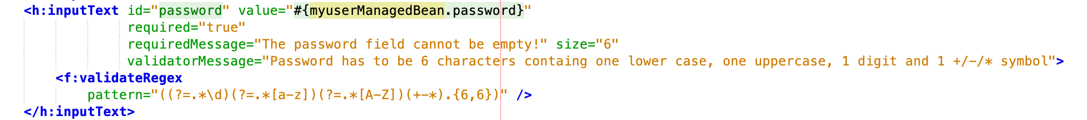

Standard validator tags are used for these instances since it is way easier to do simple validations directly in the xml files.

To match the password and cpassword (case sensitive included), a user defined validation method is implemented in the MyuserManagedBean file. Since 2 strings are being compared, it is easy and manageable to use this method to define it in the managed bean class A screenshot of a cell phone

public boolean validatePasswordCorrect() {

boolean result = false;

if (isValidPassword(password)) {

if (password.equals(cPassword)) {

System.out.println("Passwords need to match");

result = true;

}

}

return result;

}

public void validatePasswordCorrect(FacesContext context, UIComponent component,

Object value) {

*// Retrieve the value passed to this method*

String confirmPassword = (String) value;

*// Retrieve the temporary value from the password field*

UIInput passwordInput = (UIInput) component.findComponent("password");

String password = (String) passwordInput.getLocalValue();

System.out.println("Password input: " + password);

if (password == null || confirmPassword == null || !password.equals(confirmPassword)) {

String message = context.getApplication().evaluateExpressionGet(context, "#{msgs['nomatch']}", String.class);

FacesMessage msg = new FacesMessage(FacesMessage.SEVERITY_ERROR, "Passwords need to match!", "Passwords need to match!");

System.out.println("PASSWORD NOT MATCHED");

throw new ValidatorException(msg);

}

}

public String updateUser() {

String result = "failure";

boolean passwordsMatch = validatePasswordCorrect();

if (!passwordsMatch) {

return result;

}

...

**4**

During the process of completing this portfolio task, the most valuable knowledge that I have learnt is the connection between different components in 1 program (client tier, web tier, business tier, EIS tier). I learnt about the importance and mission of each tier when it comes to building a complete web app program. In task 5.1, the question about security purpose of email verification is very intriguing as it is a very important aspect of a program which is highly regard nowadays. The lack of information security is dangerously shown in current apps in the market with old-fashioned techniques, however it is also reasonable why they did so.

This lab task was a recap of what I learnt in a previous Creating Web Application unit. GUI-wise, there could had been updates with colour, picture, etc if the time allowed.

In the process of doing this lab task, there were several problems regarding to the run, deploy issues. There was time when I had to redo lab 4 in order to get lab 5 working. But fortunately, it was successful.